CSCI 5380
Network Virtualization and
Orchestration

Lab 2
OpenStack: Multi-tenants

University of Colorado Boulder
Department of Computer Science
Network Engineering

Professor Levi Perigo, Ph.D.

PART 1: OpenStack and multitenancy

Objective 1 - OpenStack: Overview

- Explain the following components of OpenStack -
- Nova - Nova is the compute service in OpenStack that creates, manages, and deletes virtual machines.
- Swift - Swift is the object storage service used to store and retrieve large amounts of unstructured data like images and backups.
- Cinder - Cinder provides block storage volumes that can be attached to virtual machines like virtual hard disks.
- Neutron - Neutron manages networking in OpenStack, including networks, subnets, routers, and IP addresses.
- Glance - Glance stores and provides virtual machine images used to launch instances.
- Keystone - Keystone is the identity service that handles authentication, authorization, users, projects, and roles.
- Horizon - Horizon is the web-based dashboard that allows users to manage OpenStack resources through a GUI.
- What is the difference between Users and Roles?
A user represents a person or service, while a role defines what actions that user is allowed to perform in a project.
- What is a hypervisor and which hypervisors are supported in OpenStack?
A hypervisor is software that allows multiple virtual machines to run on a single physical machine, and OpenStack supports hypervisors such as KVM, QEMU, Hyper-V, and VMware ESXi.
- Explain the meaning of ‘flavor’ in OpenStack.
A flavor defines the hardware configuration of a virtual machine, such as CPU, RAM, and disk size.

- Create a new network of 64 IP addresses in the Network tab and enable DHCP for 32 of the IPs using either the GUI or the CLI.
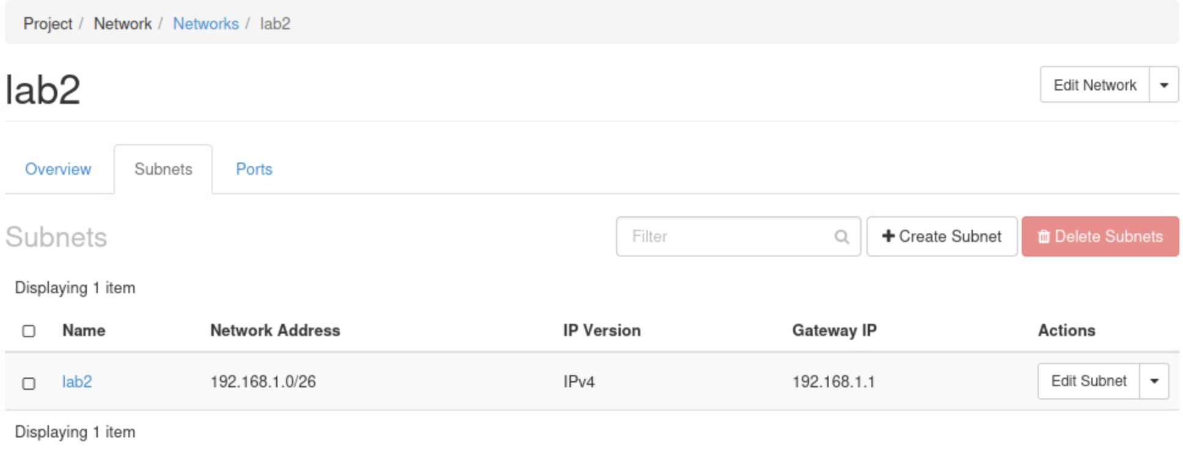
- Create a router that connects this new network with the existing “public network” using either the GUI or the CLI.
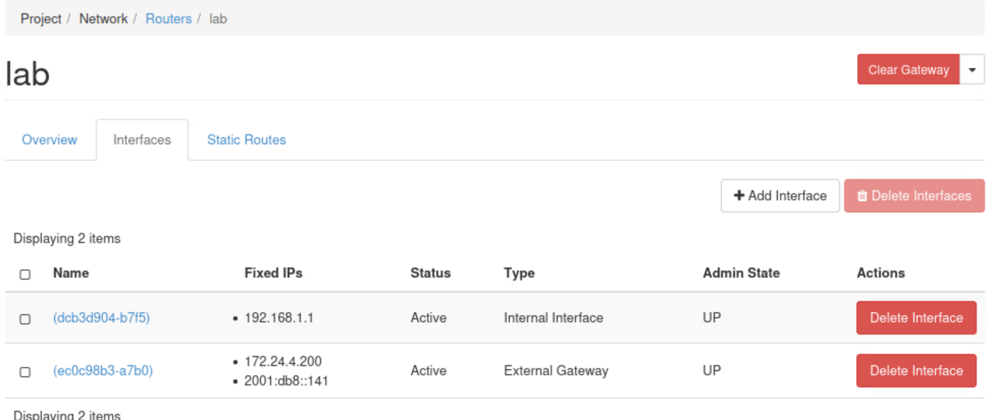
- Start two instances with the Cirros image present that connects to the new network of 64 IPs using either the GUI or the CLI.
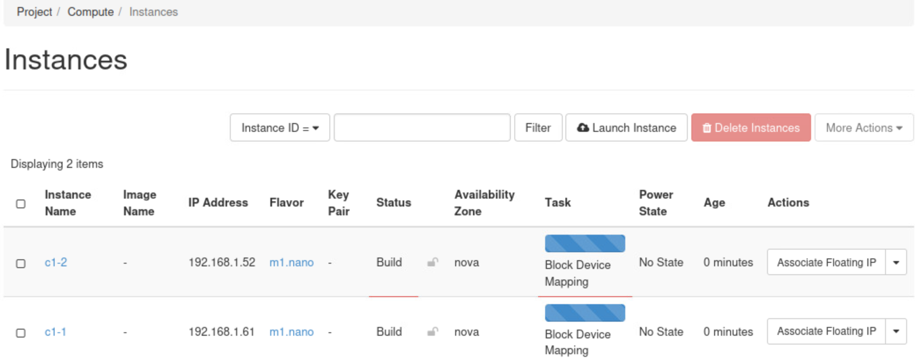

Objective 2 – Auto-scaling application using Python

- Scenario:
You are working in a cloud firm that has a single instance of an application running on OpenStack cloud platform. The firm is planning to add a functionality to the single running instance of the application that can autoscale/replicate itself to multiple instances whenever the compute capacity (eg. CPU cycles or memory) reaches a pre-defined threshold. Since you are familiar with the Python programming and REST API, you are being assigned a following task:
  - Write a simple Python application that can ssh into the available “cirros” instance that was created in the above objective and extract the CPU utilization information. [As an alternative, yo`u may use ceilometer service for retrieving this telemetry data] - Attached
  - If the CPU utilization or memory usage exceeds a threshold value, for example 20%, spin up additional instances of cirros. The creation of cirros instances should be triggered whenever the usage of CPU or memory exceeds a predefined threshold. Select CPU or memory usage to your interest to define your condition to trigger the creation of additional instances. In order to collect the utilization data, you’ll have to monitor its usage using appropriate commands.
I used the ssh based login and top command to parse the CPU usage and trigger the auto VM scale –
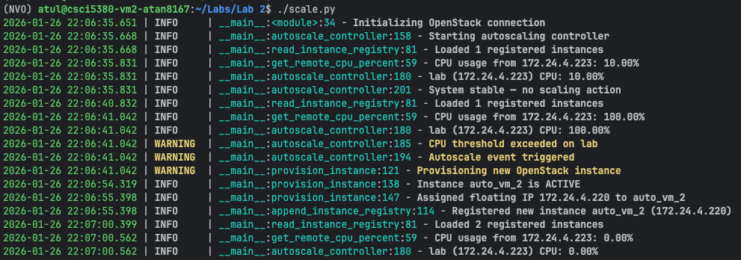
  - The Python application can use Nova REST API to create additional “Cirros” instances whenever the above condition occurs.
Additional instances are created and Floating IP is also attached in those instances automatically –
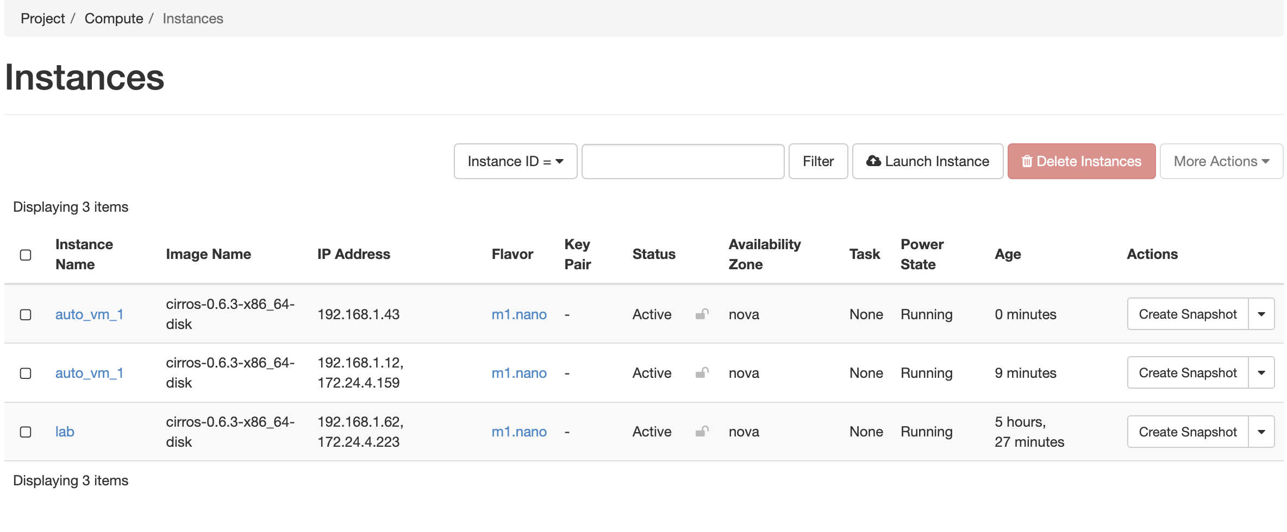
  - The auto scaling of the instances should be handled considering following requirements:
Max scaling size: 4 (this value denotes the maximum number of instances that should be spun)
Increment size: 1 (this value denotes the number of instances that should be spun whenever CPU utilization exceeds threshold)
Evaluation period: 40 (this value denotes the time period in seconds for monitoring CPU usage)
- You can use the Linux stress tool to raise the CPU utilization of an instance above the threshold.
I ran an infinite loop on the device which caused the CPU usage to go to the 100 percentage which triggered this autoscaling.
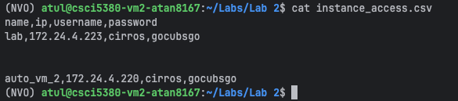

Objective 3: Multi-tenants

- In this objective, you are introduced to the function of basic tenant implementation and management with OpenStack.

- The goal is to create two virtual networks and three VMs as is shown in Figure 1.
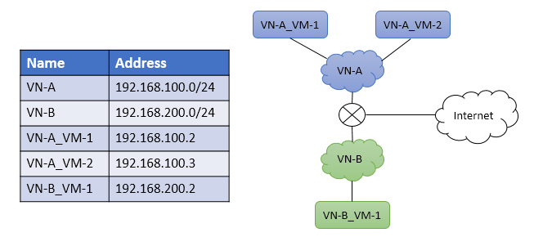
Figure 1. Final goal of Objective 3

Section 1: Creating project, user, flavor and image

- Within OpenStack UI Identity tag, create a project called lab2. Then create a user called lab2_admin and attach it to the project lab2.
Project Lab2 -
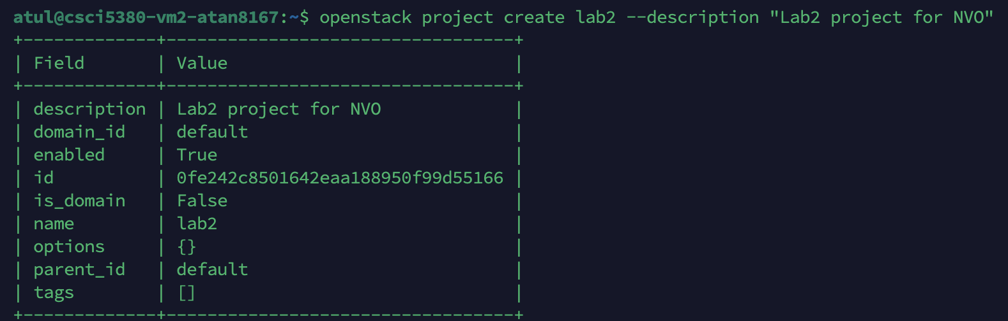
User Creation –
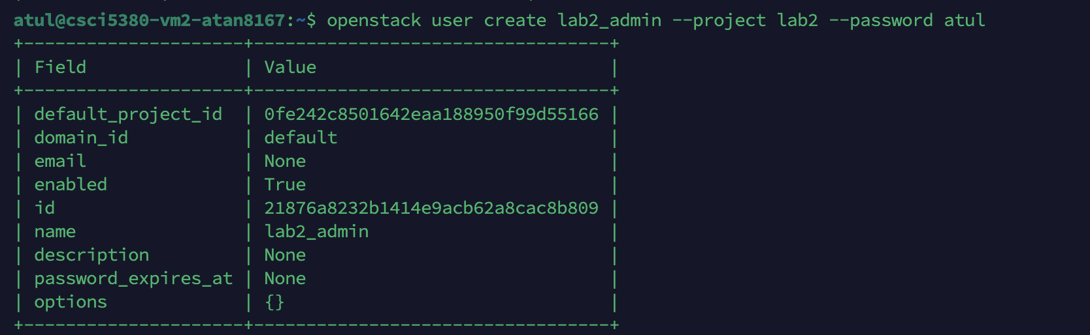
- Within OpenStack UI Admin tag, create a VM Flavor called ngn.tiny with the following setting (or the setting that works for your VM image):
vCPU = 1
RAM = 128MB
Root Disk = 1GB
Ephemeral Disk = 1GB
Swap Disk = 1GB
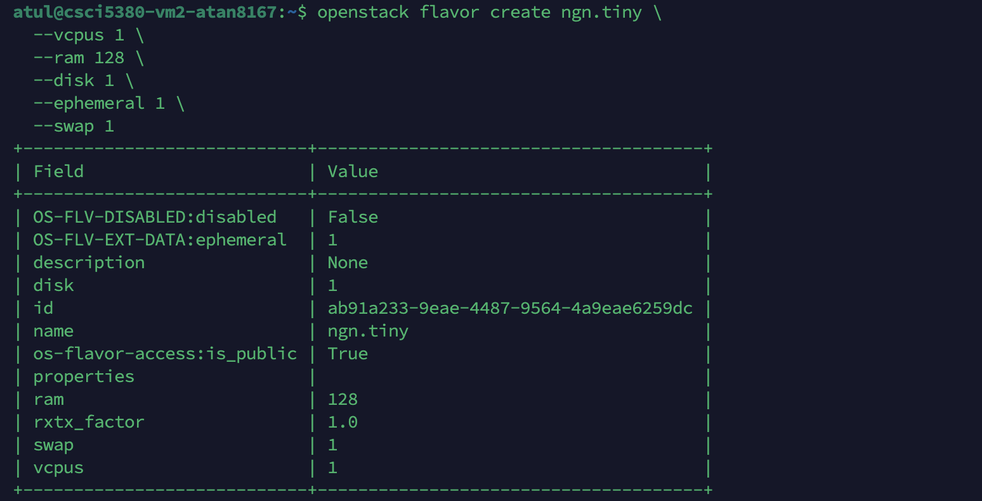
Flavor List –
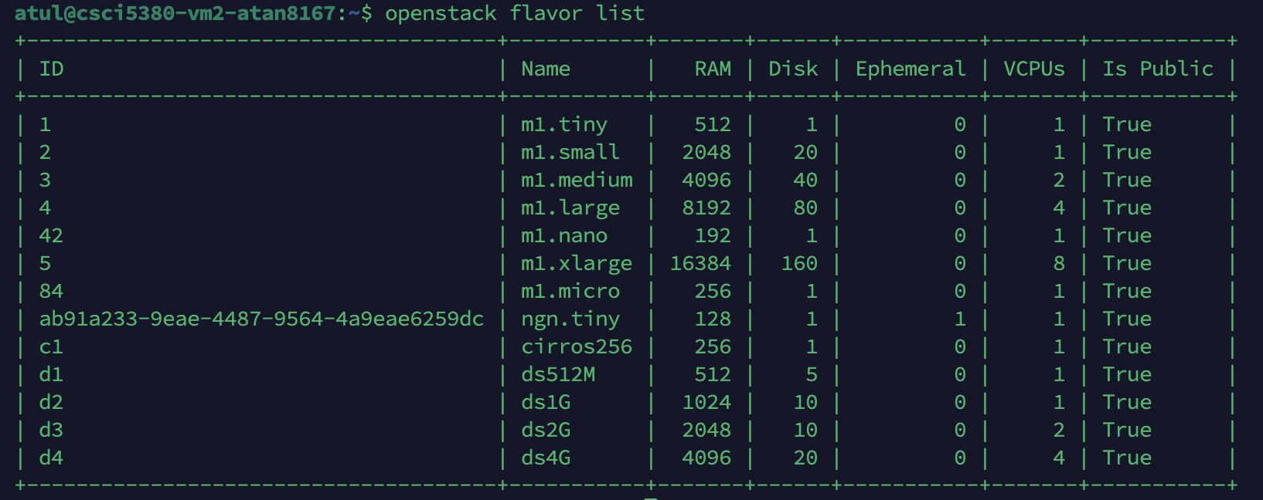
- Within OpenStack UI Admin tag, upload a VM image into OpenStack. You can use this URL: http://tinycorelinux.net/7.x/x86/release/Core-current.iso or https://docs.openstack.org/image-guide/obtain-images.html.
Remember to make it public.
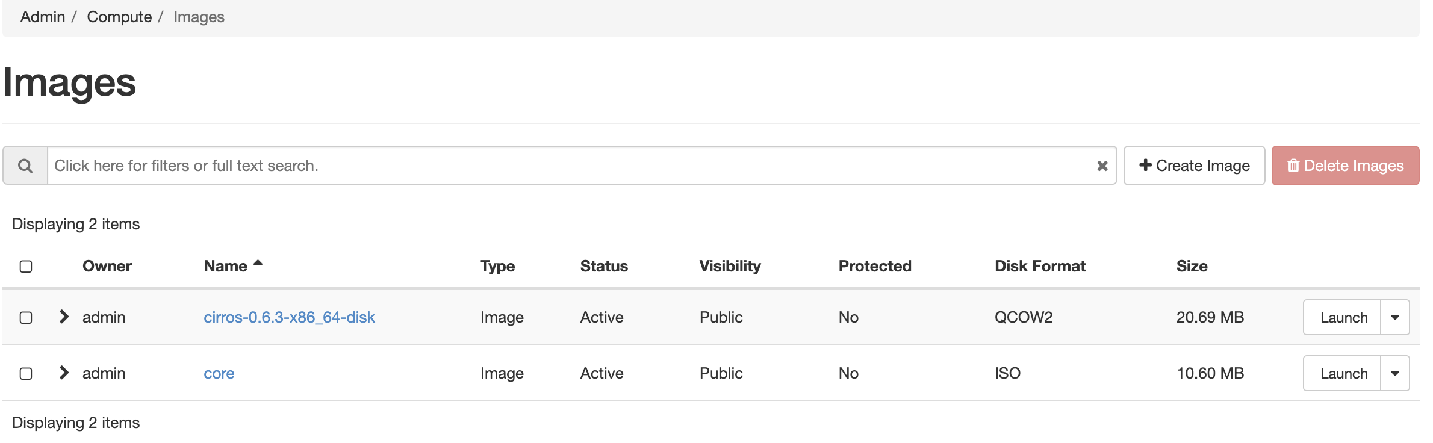
- Before proceeding, logout and login with your newly created user lab2_admin.
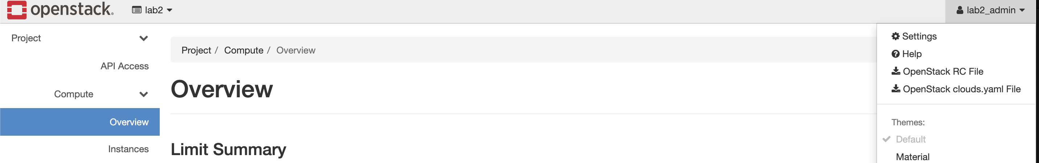

Section 2: Setup Virtual Networks

- Login back into OpenStack UI, within the Project tag, create a new Network called VN-A with network address 192.168.100.0/24. – attached
- Repeat the above steps to create a second network VN-B with network address 192.168.200.0/24.
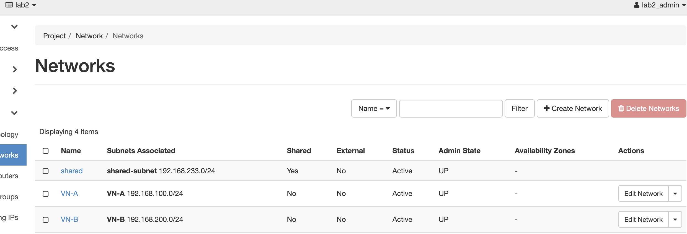

Section 3: Launch VM instances
Launch the following VMs using the flavor and image created in Section 1.
- Launch VN-A_VM-1 and VN-A_VM-2 into virtual network VN-A.
- Launch VN-B_VM-1 into virtual network VN-B.
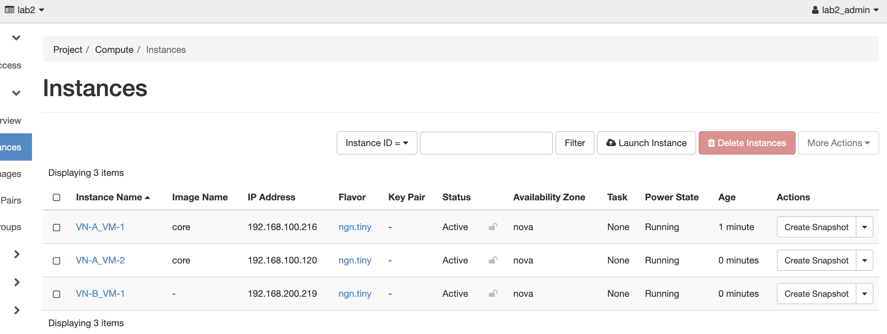

Section 4: Ping testing

- Use the console within OpenStack UI to test if VMs in VN-A can ping each other, while the VM in VN-B cannot reach VMs in VN-A.
VN-A_VM-1 to VN-A_VM-2-
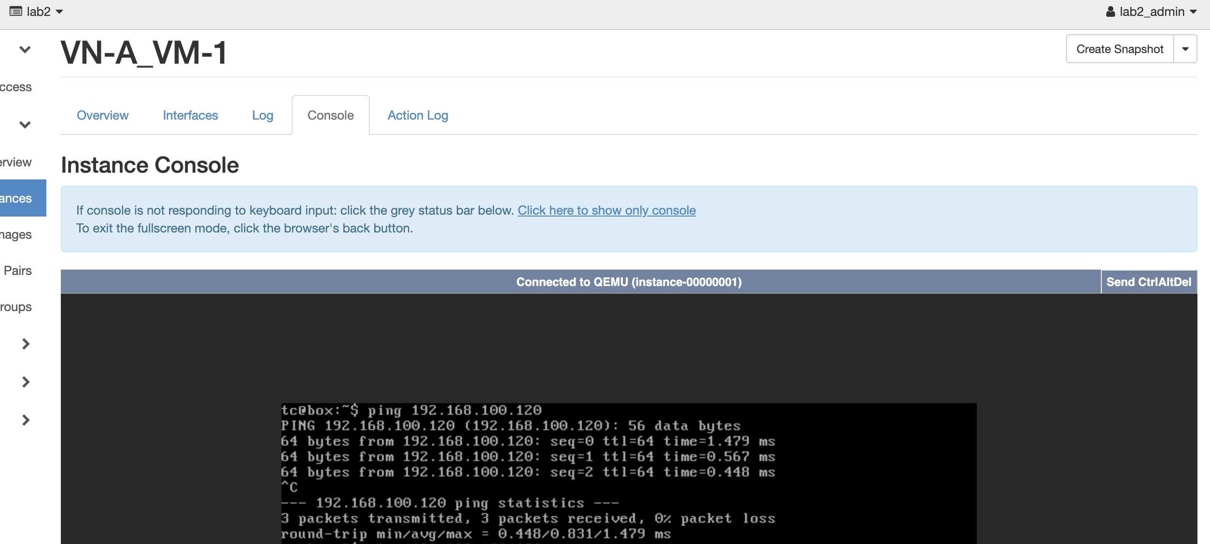
VN-B_VM1 to VM’s in VN-A-
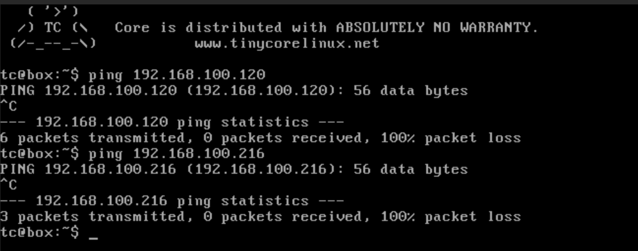
- Assign floating IPs to the VM’s both in VN-A and VN-B, and test connectivity to the Internet.
Router connected to Both the network and with internet –
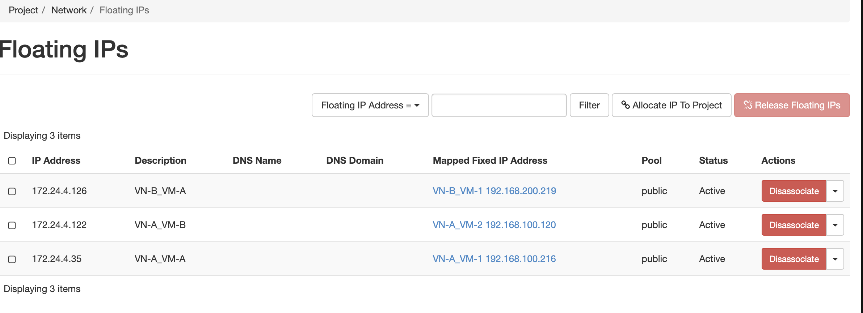
VN-B_VM-1 –Ping Success –
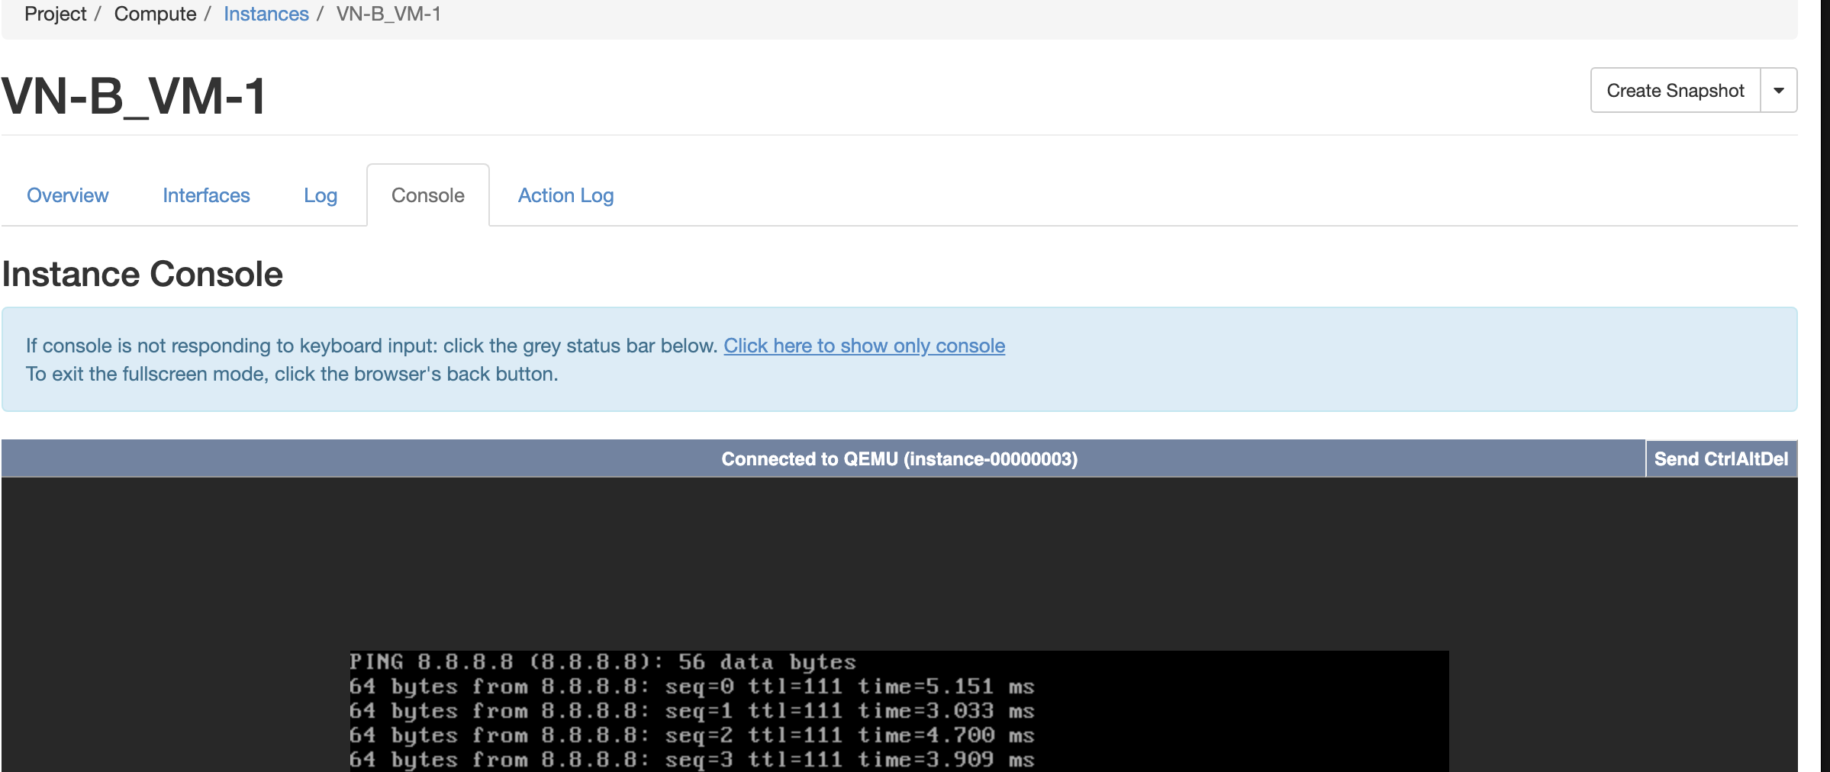
Similarly, Other VM’s in VN-A also can ping internet.

Objective 4 – Network policies in OpenStack

Summary:
In this objective, you will manage network policies within OpenStack.

Section 1: VM and Virtual Network Setup
First you will need to create the configuration as is shown in Figure 1 above.
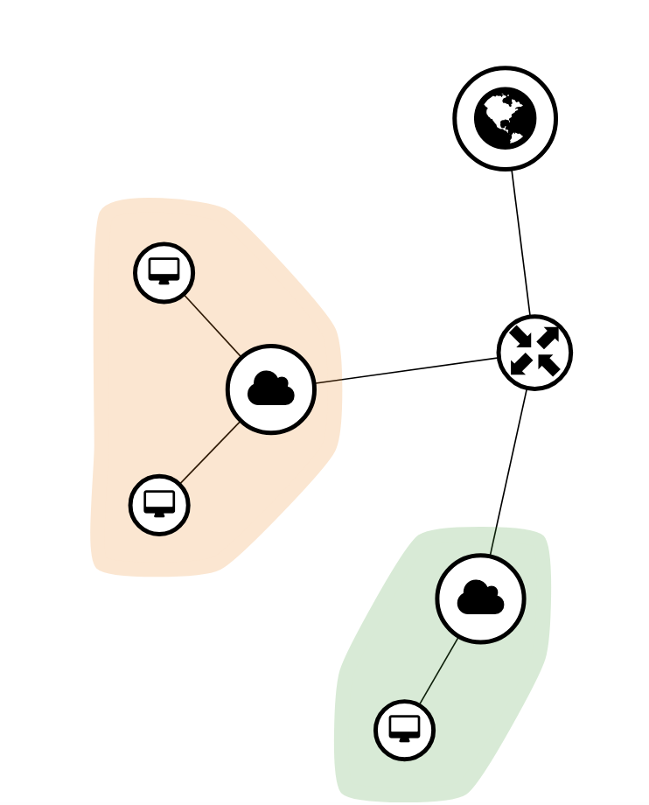

Section 2: Achieve Inter-VN Communication

The default policy allows only intra-VN communication.
- Figure out how to ping between VM’s in VN-A and VM’s in VN-B.
I created a new security group called as lab which is mapped to all the instances – This allowed me to allow the ping as well as any interesting traffic of my choice. This way I was able to ping from VN-B to VN-A as attached below.
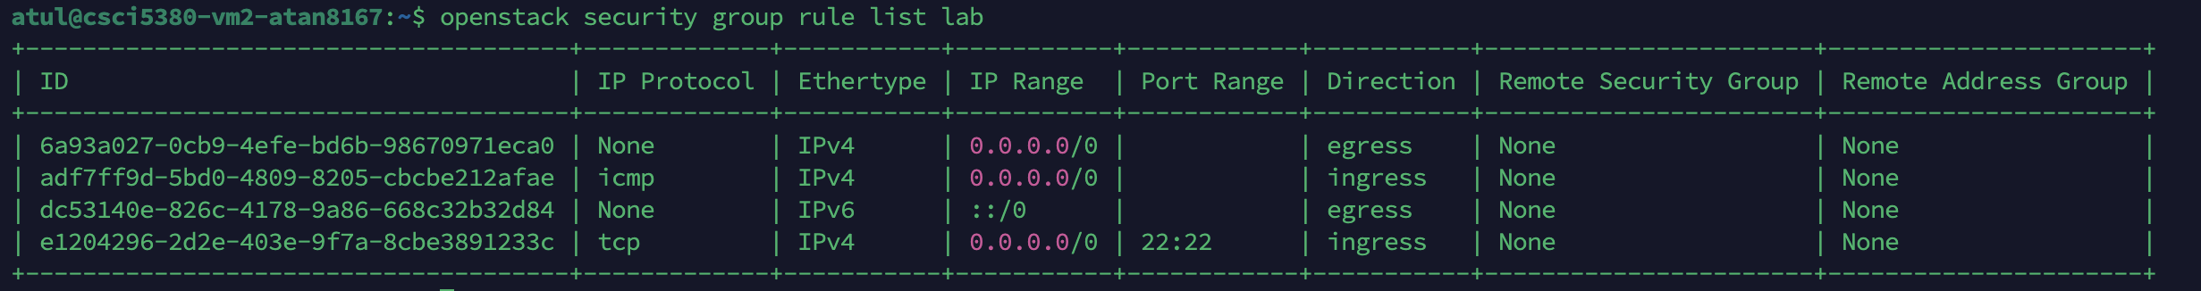
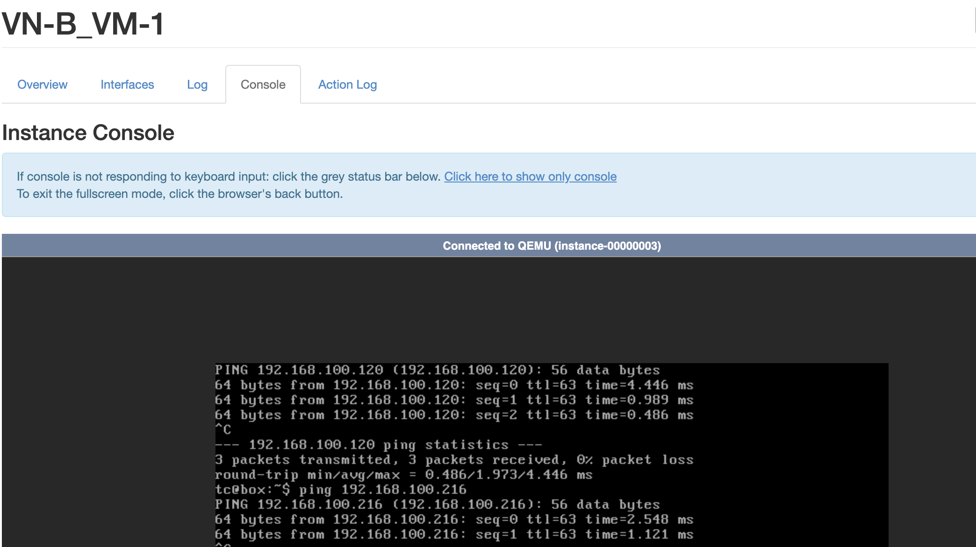
- Figure out how to ping from the VM’s out to the Internet.
Custom SG allowed to ensure rule changes by limiting the blast radius from Network.

Section 3: Network Policy Management

Now manage the network policy inside OpenStack, such that:
- VN-A_VM-1 can ping VN-B_VM-1, but VN-A_VM-2 cannot ping VN-B_VM-1.
- VN-B_VM-1 can go out to the Internet, but VN-A_VM-1 and VN-A_VM-2 cannot.
I created Security group to ensure only VM-1 can ping the VM1 in VN-B and same group restricted access to internet for VN-A also created another group for Vn-b where it restricted ingress rule from VN-A_VM-2 to ensure no ICMP reachability.
vn-a-no-internet for VN-A VMs
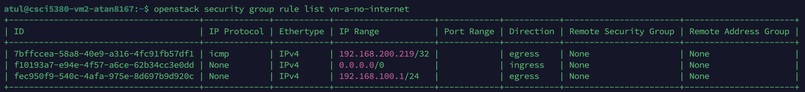
vn-b group for VN-B_hosts –
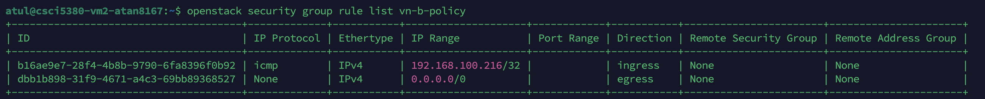
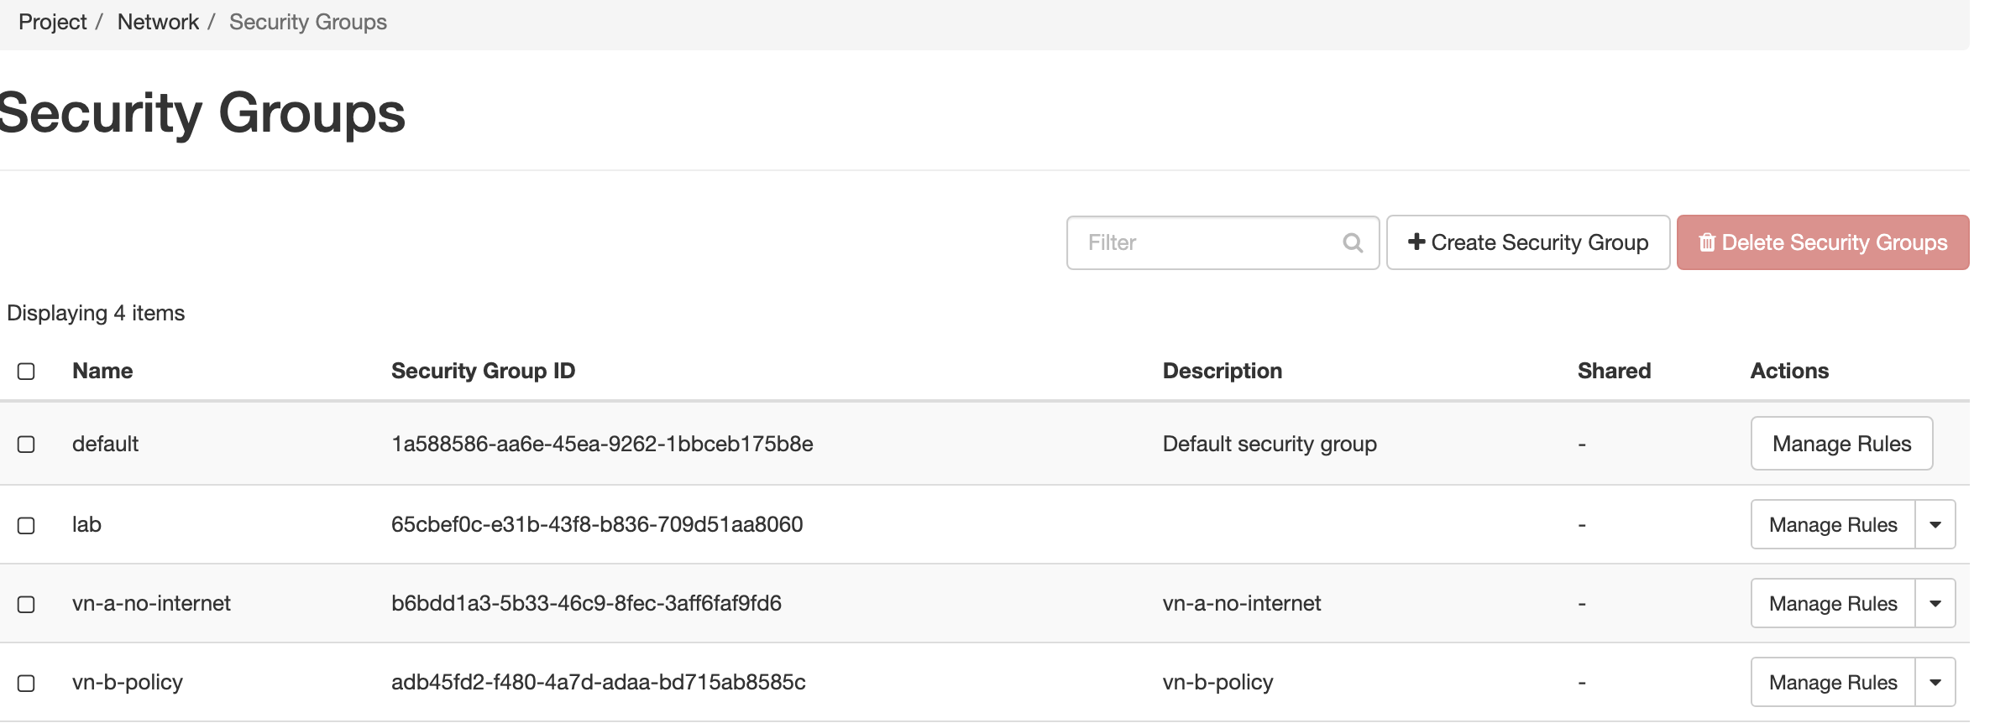

Deliverable (100 points):

Individually complete all tasks in the lab - Completed

Create a capstone group GitHub tutorial document about this lab

Create a small guide explaining/demonstrating how to achieve each objective from the lab

The individual objective guides should be divided between the team members evenly to be completed in GitHub

Submit to Canvas:

Individual Python Auto-scaling application - Attached

Document (bulleted list) of what each member contributed to GitHub tutorial document – Not applicable

Include a link to the GitHub page

https://github.com/atulanand25/NVO/

